# Without GHMC area results:

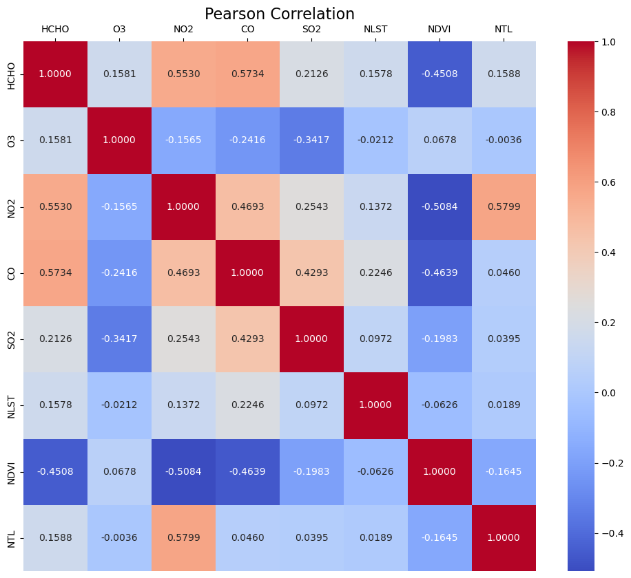

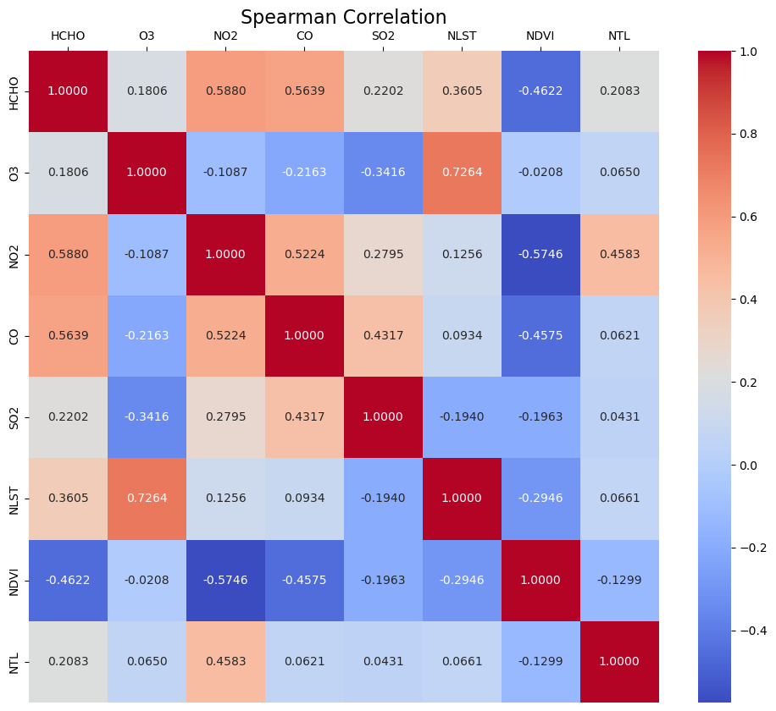

Regression:

Average Air pollution = -0.32592194 NDVI + 0.28060254 NLST + 0.14290371 NTL

HCHO = -0.51117334 NDVI + 0.38714985 NLST + 0.181947 NTL

O3 = 0.06354255 NDVI + -0.05735222 NLST + 0.03393076 NTL

NO2 = -0.59215569 NDVI + 0.33791258 NLST + 0.15712434 NTL

CO = -0.39304159 NDVI + 0.47752479 NLST + 0.08458737 NTL

SO2 = -0.19678161 NDVI + 0.25777768 NLST + 0.2569291 NTL

GHMC area results:  
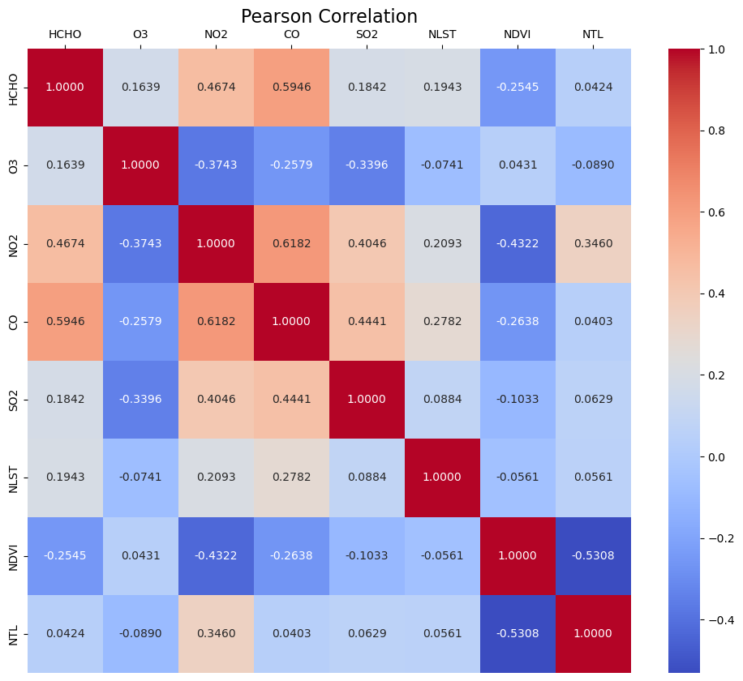

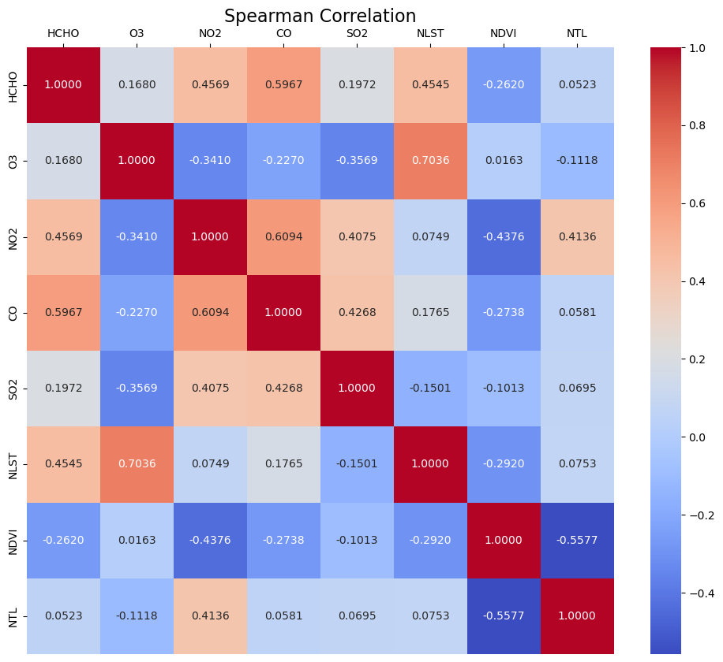

Regression:

Average Air pollution = -0.29360884 NDVI + 0.23262996 NLST + 0.084568 NTL

HCHO = -0.44650192 NDVI + 0.33146558 NLST + 0.01049771 NTL

O3 = -0.0098661 NDVI + -0.04936723 NLST + -0.4094445 NTL

NO2 = -0.48860283 NDVI + 0.27611827 NLST + 0.49761246 NTL

CO = -0.37135992 NDVI + 0.45483579 NLST + -0.06902231 NTL

SO2 = -0.15171343 NDVI + 0.1500974 NLST + 0.39319664 NTL